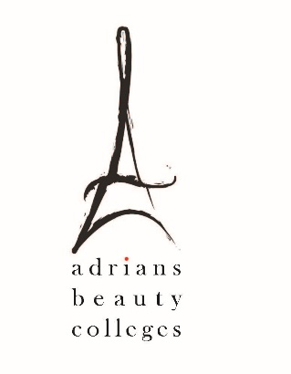

Gainful Employment Disclosures – 2019

Program Name: Cosmetologist

This program is designed to be completed in 53 weeks.

This program will cost $ 19,260.26 if completed within normal time. There may be additional costs for living expenses. These costs were accurate at the time of posting, but may have changed.

Of the students who completed this program within normal time, the typical graduate leaves with $ 9,500.00 of debt.

- Program meets licensure requirements in the following States: California
- Program qualifies students to sit for licensure exam in the following States: California
For more information about graduation rates, loan repayment rates, and post-enrollment earnings about this institution and other postsecondary institutions please click here: https://collegescorecard.ed.gov/

Warning Language
This program has not passed standards established by the U.S. Department of Education. The Department based these standards on the amounts students borrow for enrollment in this program and their reported earnings. If in the future the program does not pass the standards, students who are then enrolled may not be able to use federal student grants or loans to pay for the program, and may have to find other ways, such as private loans, to pay for the program.

