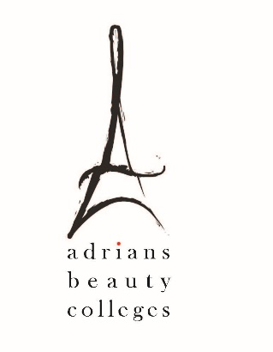
Gainful Employment Disclosures – 2019

Program Name: ESTHETICIAN

This program is designed to be completed in 20 weeks.

This program will cost $9997.09 if completed within normal time. There may be additional costs for living expenses. These costs were accurate at the time of posting, but may have changed.

Of the students who completed this program within normal time, the typical graduate leaves with $ [XX,XXX] of debt.
“Fewer than 10 students completed this program within normal time. This number has been withheld to preserve the confidentiality of the students.”

- Program meets licensure requirements in the following States: California
- Program qualifies students to sit for licensure exam in the following States: California

For more information about graduation rates, loan repayment rates, and post-enrollment earnings about this institution and other postsecondary institutions please click here: https://collegescorecard.ed.gov/

